ARCHITECT REVIEW
SALDEV 1427 QCP Cloning Logic Architect Review
FlywirePartial | Read-only stepped-pricing JavaScript and Apex best-practice review
Source | SALDEV-1427 | FlywirePartial Enterprise sandbox 00DhG0000000jOXUAY
Scope | 2 QCP scripts | 1 trigger | 1 handler | 1 test class
Review date | 4 September 2026
Validation mode | Live read-back | JS syntax | focused Apex tests | check-only
Decision | NO-GO - Changes Requested before QA or promotion
Boundary | Read-only review; no record, metadata, activation, or deployment changes

ARCHITECT DECISION
Changes Requested. SALDEV-1427 is not release-ready: QCP dependencies are incomplete, Domestic_Sponsor__c is not a real quote-line field, usage fields are simultaneously read-only and editable, lineage matching is ambiguous, and check-only failed at 43.59% trigger coverage.

Acceptance and quality outcome
# | Scope | Result | Evidence
1 | ARR values cleared on SUP clones | NOT PROVEN | Nulling lists exist, but dependencies omit the fields and one API name is invalid.
2 | First group remains editable | PARTIAL | An editable allowlist exists; no live QLE functional run was performed.
3 | Later groups are restricted | DEFECT | The script reads group Source and Number, but they are not declared dependencies.
4 | Usage price fields editable | FAIL | Usage_Rate__c and Usage_Rate_Amt__c are also globally read-only; that rule wins.
5 | Opportunity Line ID lineage | HIGH RISK | Quote + Product cannot distinguish group, bundle, configuration, or ship-to context.
6 | Required scenario matrix | FAIL | No JavaScript unit evidence; Apex assertions miss Group 2; check-only failed coverage.

Runtime path and defect concentration
SALDEV-1427 spans QCP configuration, QLE editability, and Apex Opportunity Line ID lineage. The code has a useful bulk-processing base, but several runtime contracts and the release gate remain incomplete.
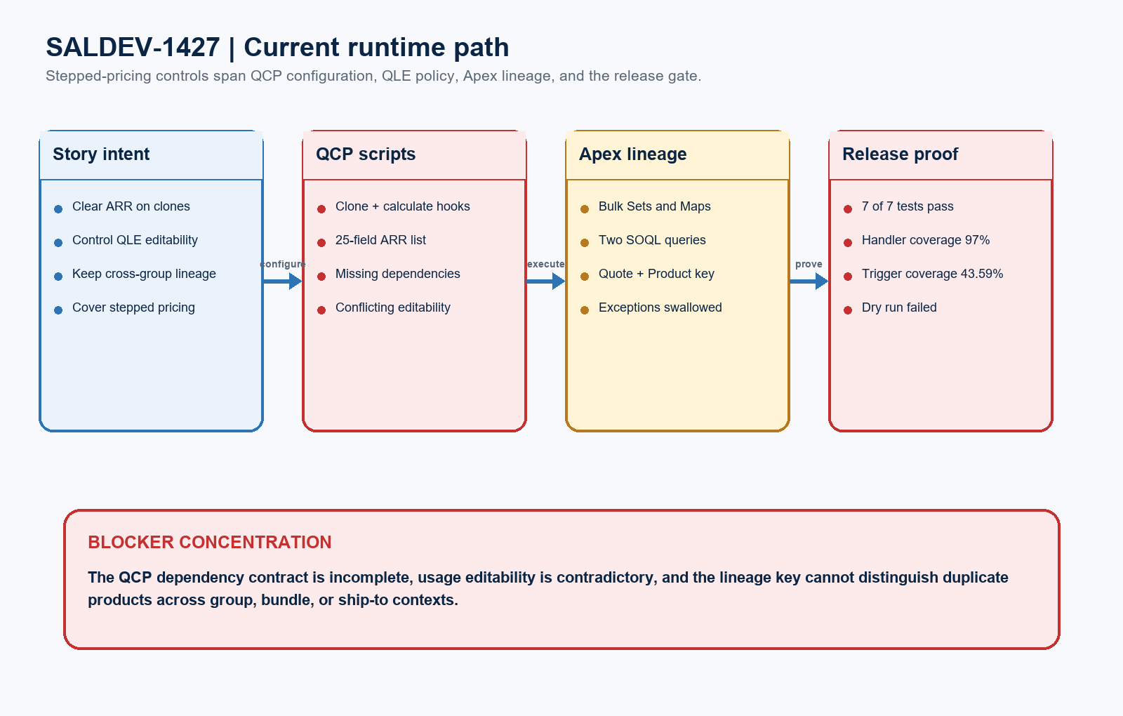
Figure 1. SALDEV-1427 implementation path and release blockers
DESIGN READING
Blue shows the intended contract. Green shows practices worth retaining. Amber marks incomplete proof. Red identifies issues that can create incorrect quote-line behavior or block release.

Detailed code and validation evidence

1. Live component and runtime evidence
Evidence area | Observed result | Evidence
Target org | Verified sandbox | FlywirePartial is org 00DhG0000000jOXUAY; Enterprise Edition; IsSandbox=true.
QCP_HideFieldInQLE | Runtime present | 1,999 JavaScript lines; transpiled runtime exists; syntax check passed.
QLE_CloneLineHandler | Runtime present | 58 JavaScript lines; clone hook and runtime exist; syntax check passed.
Apex runtime | Bulk-structured | Trigger delegates to a with-sharing handler using Sets, Maps, and two SOQL queries outside loops.
Field read-back | 24 of 25 found | Domestic_Sponsor__c does not exist; Processed_Volume_Amount__c is correctly excluded.

2. Best-practice findings
Finding | Severity | Evidence
Dependency contract | BLOCKER | Clone script omits all ARR dependencies; QCP omits required line and group dependencies.
Rule precedence | BLOCKER | Two usage fields are both globally read-only and ramp-editable; read-only executes first.
Lineage determinism | HIGH | Occurrence order can cross bundles or ship-to groups; fallback reuses the first master ID.

3. Test and validation evidence
Test / boundary | Status | Evidence
Focused Apex suite | PASS | 7 of 7 QuoteLineTriggerHandlerTest methods passed; zero failures.
Handler coverage | PASS | QuoteLineTriggerHandler measured 97%.
Trigger coverage | FAIL | QuoteLineTrigger measured 43.59%; Salesforce requires at least 75%.
Check-only package | FAILED | 0AfhG000001da33SAA: 3/3 components and 7/7 tests, but coverage failed; nothing deployed.
Behavior proof | MISSING | No JavaScript suite or live QLE matrix; the second-group Apex outcome is not asserted.

Required target architecture and proof model
The release-ready design should centralize the ARR field contract, declare every QCP dependency, make editability precedence explicit, correlate lineage deterministically, and prove JavaScript and Apex behavior independently.
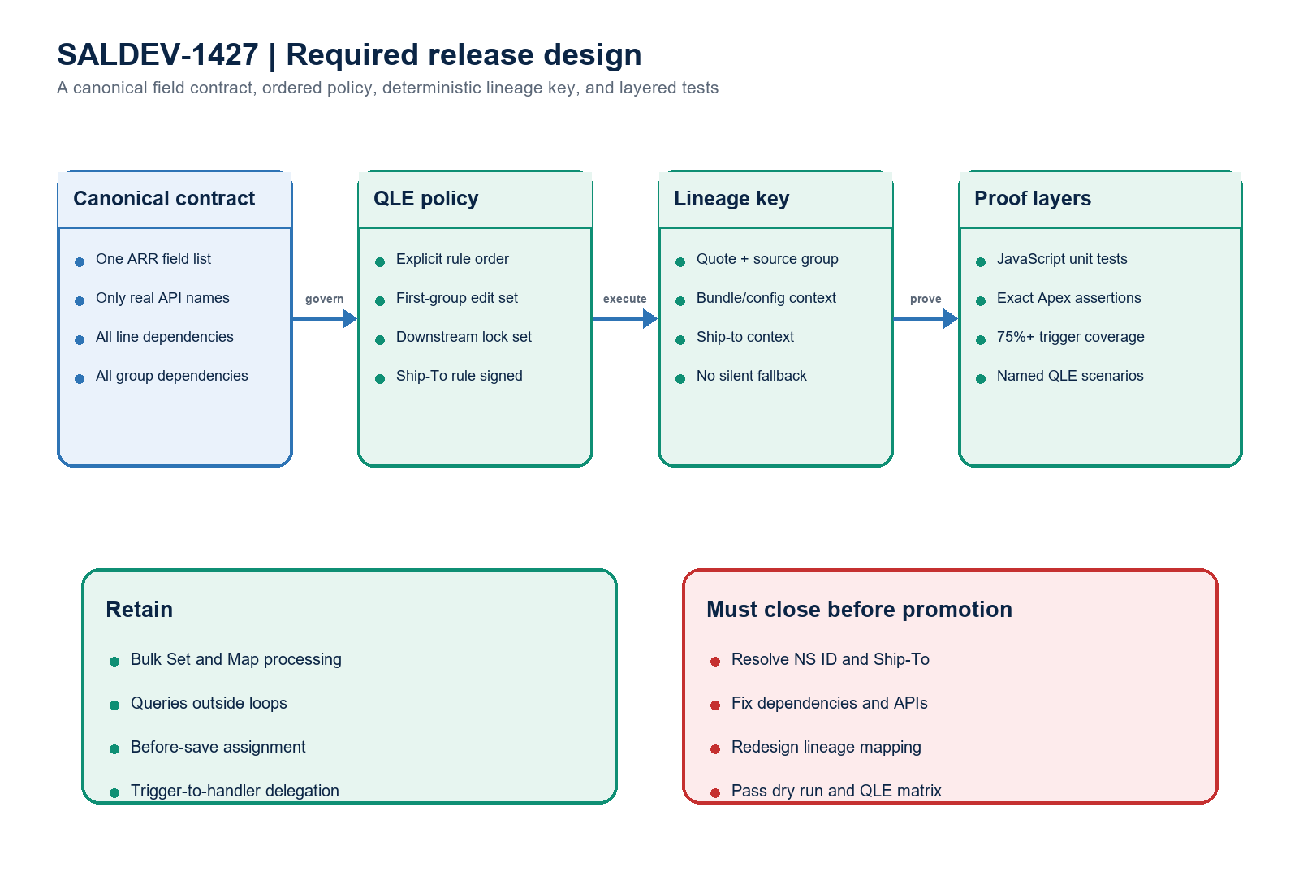
Figure 2. SALDEV-1427 required data contract, lineage design, and proof layers
Architect interpretation: the Apex handler is bulk-structured, but QCP configuration and identity semantics are executable parts of the solution. Passing handler tests cannot compensate for missing dependencies, contradictory rules, ambiguous lineage, or insufficient trigger coverage.

Required completion gates
Gate | Required action | Owner | Evidence needed
1 | Correct APIs and QCP dependencies | CPQ Developer | All line/group APIs exist and are declared; remove or correctly map Domestic_Sponsor__c.
2 | Make editability precedence explicit | CPQ Developer | Usage fields work as intended in first and downstream groups.
3 | Redesign lineage correlation | Apex Developer | Deterministic source/group/bundle/ship-to key; no silent fallback.
4 | Resolve story semantics | Product Owner | Signed NS ID, Ship-To, amendment, and SALDEV-1404 dependency decisions.
5 | Add exact automated tests | Developer / QA | JavaScript tests plus Apex assertions for every group, duplicate product, bundle, and ship-to case.
6 | Re-run release and QLE proof | Dev Lead / QA | 75%+ trigger coverage, successful check-only, and named SUP functional read-back.

Ready-to-paste architect response
STORY COMMENT
Architect review completed for SALDEV-1427 in FlywirePartial. Decision: Changes Requested / NO-GO before QA or promotion. Both QCP scripts pass syntax checks; the with-sharing Apex handler is bulk-structured; 7 of 7 focused tests passed; and handler coverage is 97%. Blockers remain: incomplete QCP dependencies, nonexistent Domestic_Sponsor__c, conflicting usage-field editability, ambiguous Quote + Product lineage, swallowed exceptions, and missing JavaScript and exact Group 2 assertions. Check-only 0AfhG000001da33SAA validated 3 of 3 components and ran 7 passing tests, but failed because QuoteLineTrigger coverage is 43.59%, below 75%. Nothing deployed. Resolve requirements, correct the field contract, redesign deterministic mapping, add the missing tests, pass check-only, and complete the named stepped-pricing QLE matrix before resubmission.

Evidence boundary
Evidence: the SALDEV-1427 source document, verified FlywirePartial sandbox and scripts, retrieved Apex and field metadata, syntax checks, focused tests, and check-only validation. No Salesforce record or metadata changes, deployment, activation, promotion, or Production action occurred.

